|  |
| --- |
| **Restaurant Management System** |
|  |
|  |
| **AYUSH JAIN**  **Cosmic-R** |
|  |
|  |
|  |

**ABOUT THE PROJECT**

This project is designed to be used in a restaurant using structures and files. It consists of 4 main operations which are:

Login: - It enters the details about the user such as the login id, login password and id type.

Menu: - It enters the items of the menu through the administrator along with the prices. It displays the menu in a different function and it modifies the menu in another function.

Order: - It first displays the entire menu the user can select from the menu and place an order.

Stock: - the stock is managed by the administrator and it can modify the stock according to the input.

**MAIN TOPICS**

**Structures:**

Stock: - This structure is used for handling stock details which includes item name and quantity.

Login: -This structure is used for handling login details which includes login Id, password and account type.

Date: - This structure is used for handling date which includes day, month and year.

Order: - This structure is used for handling order details which includes name, phone number, item code, price and date.

Menu: - This structure is used for handling menu details which includes dish name, code and price.

**Functions:**

Elogin() :- function used for entering the login details

Emenu() :- function used for entering the menu details

Eorder() :- function used for entering the order details

Estock() :- function used for entering the stock details

Main() :- this function is used to handle all the functions

Momenu() :- function used for modifying the menu details

Mstock() :- function used for modifying the stock details

Selogin() :- function used to search from login details

Shlogin() :- function used to show login details

Shmenu() :- function used to show menu details

Shorder() :- function used to show order details

Shstock() :- function used to show stock details

Sshorder() :- function used to show particular order

Xit() :- function used to exit the program

**Files:**

Login: - This file saves all the data related to login which includes login Id, password and account type.

Menu: - This file saves all the data related to the menu items which includes dish name, code and price.

Stock: - This file saves all the data related to the stock which includes item name and quantity.

Order: - This file saves all the data related to the orders which includes name, phone number, item code, price and date.

**HEADER FILES USED**

**#include <stdio.h>:**  is a statement which tells the compiler to insert the contents of stdio at that particular place.

Stdio.h is the header file for standard input and output. This is useful for getting the input from the user (Keyboard) and output result text to the monitor (screen). Without this header file, one cannot display the results to the users on the screen or cannot input the values through the keyboard.

**#include <conio.h>:**  the conio.h header file contains certain library functions that let us perform input and output operation.

Functions like printf (), getch () and scanf () need “#include<conio.h>” header file to be included for us to use them in our program.

**#include <string.h> :** It is the header in the C standard library for the C programming language which contains macro definitions, constants and declarations of functions and types used not only for string handling but also various memory handling functions.

Functions like str.cmp ( ) need “#include<string.h>” header file to be included for us to use them in our program.

**#include <dos.h> :** Dos.h header file of C language contains functions for handling interrupts, producing sound, date and time functions etc.

Functions like “sleep” need “#include <dos.h>” header file to be included for us to use them in our program.

**Code Snippets**

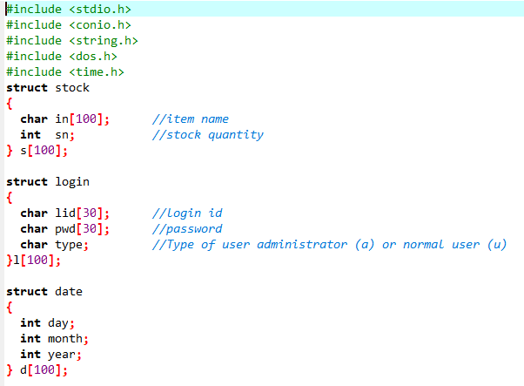

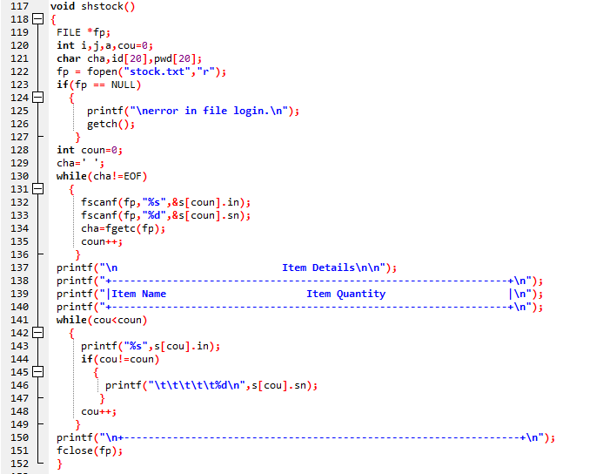

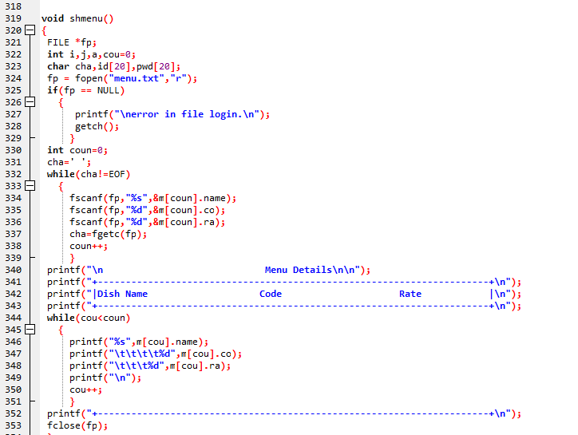

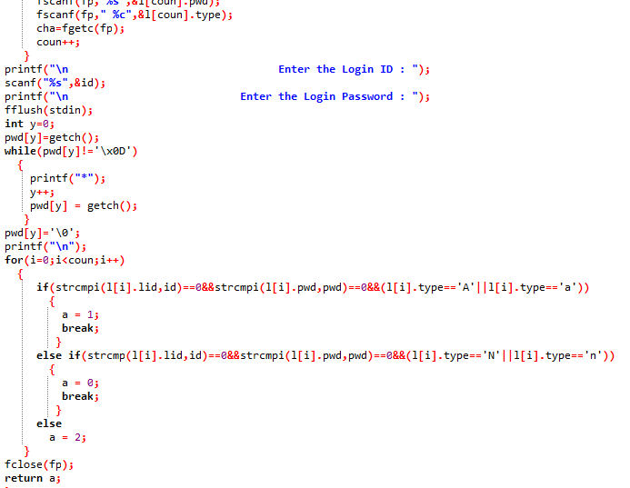

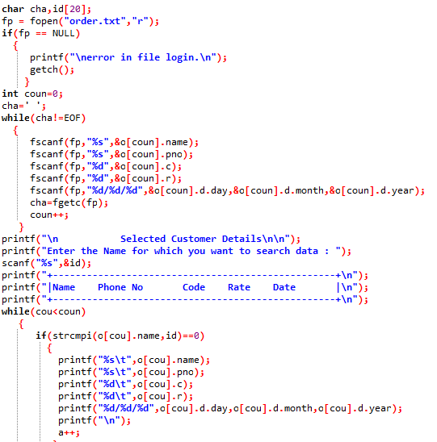

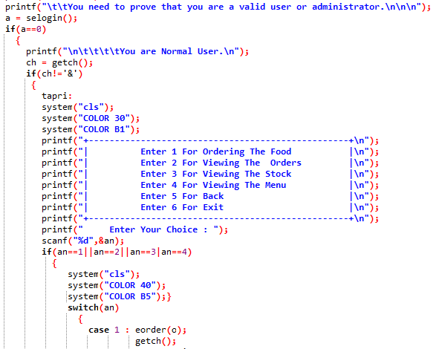

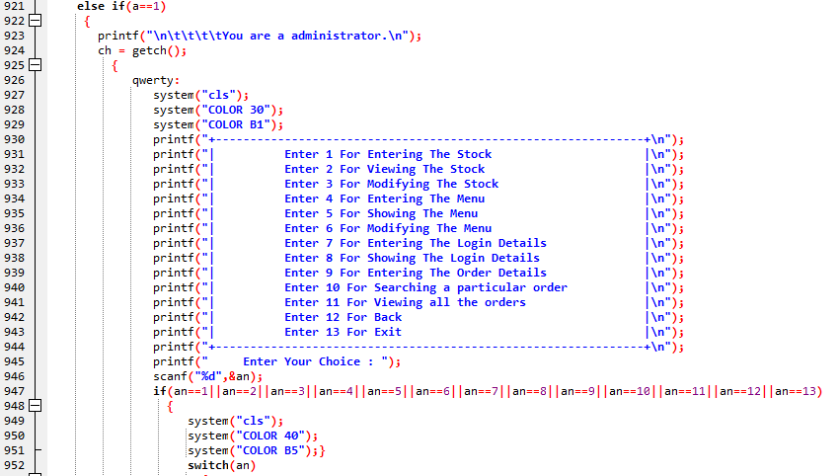

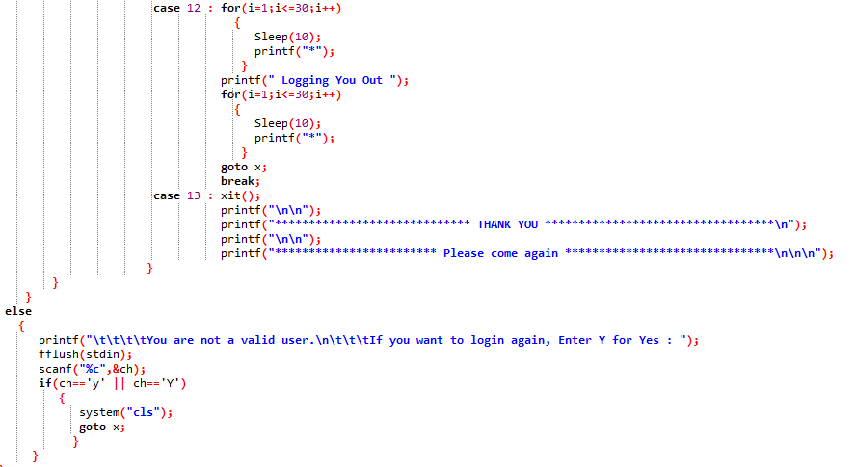

**Output Photos**

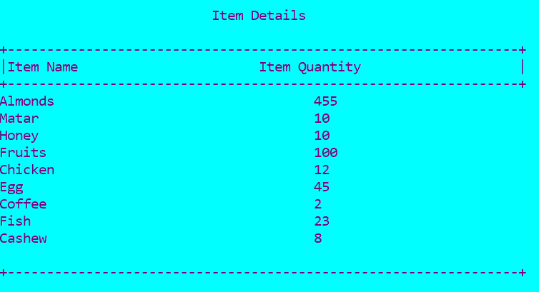

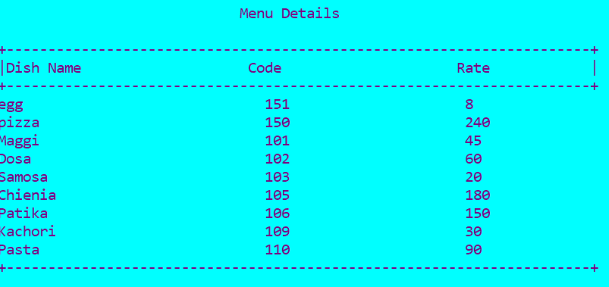

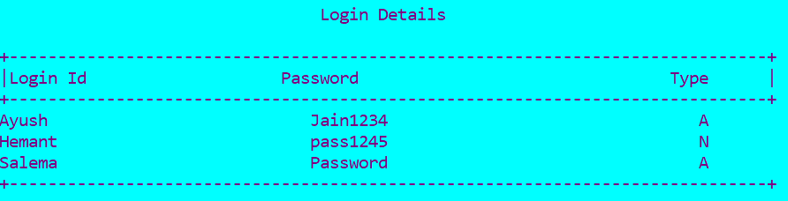

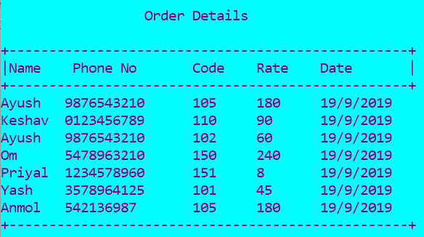

**Conclusion**

To summarize, this project is about managing restaurants. It will be helpful in many restaurants as it makes it easier for the administrators, waiters as well as the customers.